Wheel Shape Transformer

Robo Club IITG

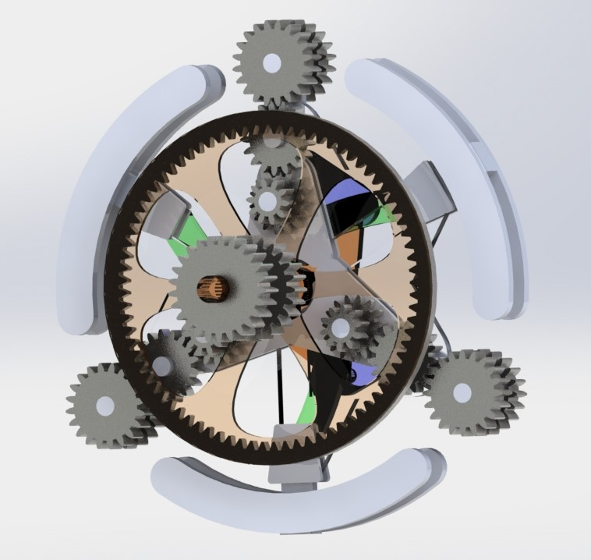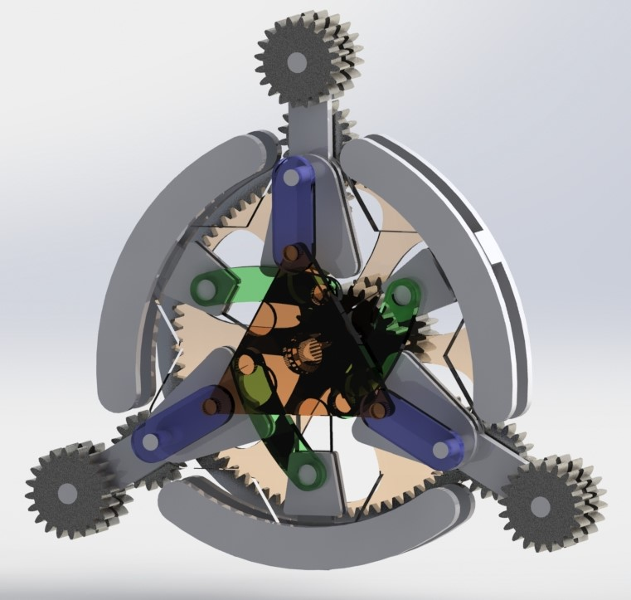

All parts can be Laser cut from acrylic/ some can be 3D printed as per requirement, resulting in easy of replication, less investment and further prototype testing.

The Circular Configuration:

This offers less traction but way better mobility and speed to the wheel for flat/ smooth surfaces.

The whole system rotates in direct transmission with the drive shaft and makes the vehicle move.

Circular Configuration (Back view)

Triangular Configuration (Front view)

The Triangular Configuration:

This offers better traction and more stability over rocky/uneven/sandy terrains.

Only the outer chain rotates, connected indirectly to the drive shaft with gear mechanism,

This Project focusses on the idea of transforming the wheel shape during vehicle locomotion to enhance the surface traction properties of the wheels and enable the vehicle to move on uneven surfaces.